# Week 3 Submission Group: 19

Word limit=1000. Use bullet points and be concise. Cite reference

# Project Update: 1 point

1. What is the purpose and task in this step?

The purpose of this task is to choose a final design by using a decision matrix or any appropriate decision-making tool, and then fully develop that design.

The final design comprises a solid model and an exploded assembly containing a bill of materials.

1. What did you achieve in this step? Also submit two CAD drawings in a separated PDF file (A3 size with UC template, 1* solid model in colours, 1* exploded view of assembly with BoM)

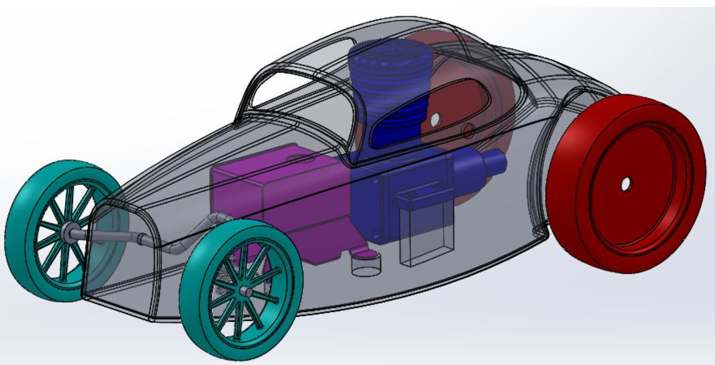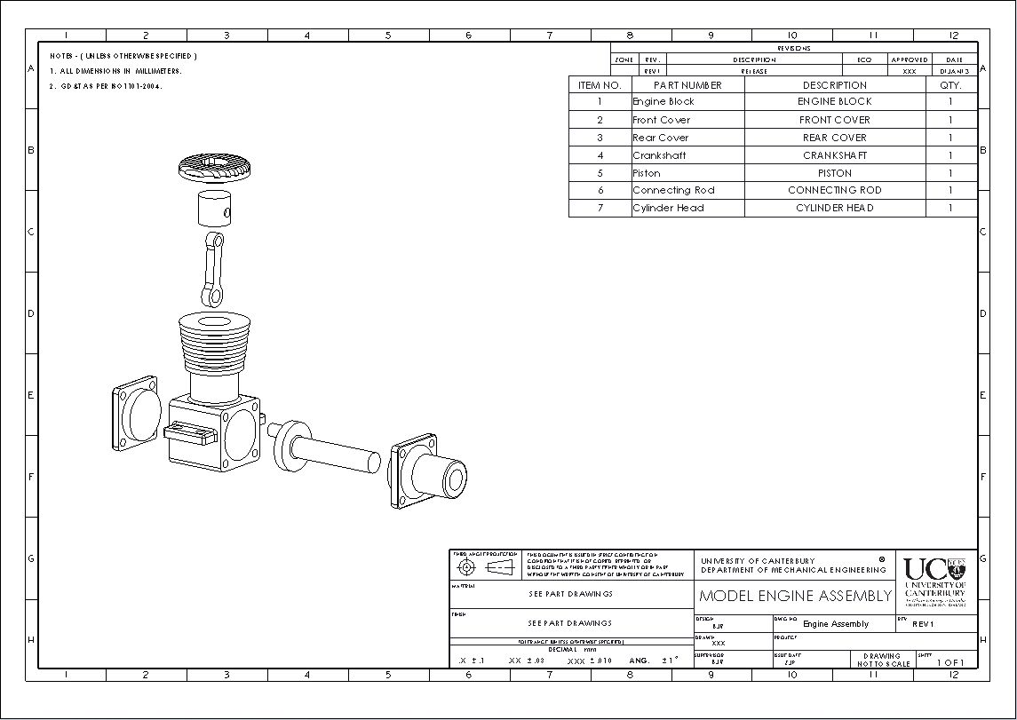

This KT table was used to compare each of our design concepts.

|  |  |  |  |  |  |  |  |  |  |
| --- | --- | --- | --- | --- | --- | --- | --- | --- | --- |
| Ideas | Easy assembly/disassembly | Accuracy | Smooth movements | Easy manufacturing | Cost | Safety | Number of parts | Total w/o # parts | total w/ parts |
| Weight | 10 | 10 | 7 | 5 | y/n | 6 | 4 |  |  |
| 1 | 8 (1) | 5(4) | 9(1) | 6(2) | y/n | 5 | 15(1) | 253(9) | 193 |
| 2 | 5(4) | 8(2) | 8(2) | 4(4) | y/n | 5 | 15(1) | 236(13) | 176 |
| 3 | 6(2) | 7(3) | 4(4) | 7(1) | y/n | 5 | 20(3) | 223(13) | 143 |
| 4 | 6(2) | 9(1) | 8(2) | 6(2) | y/n | 5 | 20(3) | 266(10) | 186 |

We chose design 1: cylindrical coordinates.

This design was then modelled to show what parts must be manufactured or bought as well as their functions. Two CAD drawings were created that shows the final design and an exploded view of each part with a BoM.

# Homework: 1 point

1. A tube with a rectangular cross section is to be fabricated by stereolithography. Outside dimensions of the rectangle are 38 mm by 60 mm, and the corresponding inside dimensions are 30 mm by 52 mm (wall thickness = 4 mm except at corners). The height of the tube (z-direction) = 40 mm. Layer thickness = 0.10 mm, and laser spot diameter = 0.25 mm. The beam velocity across the surface of the photopolymer = 800 mm/s. Compute an estimate for the cycle time to build the part, if 20 s are lost each layer for repositioning and recoating. Ignore setup time. (2.622hr)

(Length of each line * number of lines per section * number of sections with that line length * number of layers) / surface velocity + number of layers * layer set up delay

1. Individual reflection in each step (1-3): what did you learn in step 1-3, and highlight those that you taught yourself in green colour? What did you like about the project and what would you like to be changed? What was your best contribution to the group’s success (give a specific example)? If you were to do this project again, what would you do differently?

Lucas Kwan, ID: 44768081

In step 1 I learned about how important it is to fully define the problem. The further we progressed in this project, the more we relied on our defined considerations and constraints from the first week.

In step 2 I learned that even strange design concepts can still be a viable solution. Most pre-existing CNC machines use cartesian coordinates and so most of our ideas used this system. An idea I brought up was a CNC machine that used cylindrical coordinates. After evaluating each idea with a KT table, the cylindrical coordinate idea was chosen.

In step 3 I learned that designing a complete assembly takes a lot of time and effort. I oversaw designing the soldering iron feeder and holder. Designing these parts to not only fit our criteria and constraints set, but also to follow DfMA was difficult.

In this project I liked having detailed weekly milestones, but the due date isn’t fair for the later groups, and meeting outside of lab times is difficult to organize.

My best contribution was the cylindrical coordinate system concept.

Next time I would have more meetings throughout the week.

Jack Edwards, ID: 51427661

Step 1 taught me how essential it is to fully define the problem because as the project progressed we relied on the constraints we defined in the first week.

Step 2 taught me that a standard design isn’t necessarily the only design. This was shown by our group having the unique idea of using cylindrical coordinates. This was different from available products which all used cartesian coordinates. My concept design was like standard CNC machines.

Step 3 taught me that there are lots of hidden details in designs that can be missed at first glance. I helped calculate the gear ratio for the trade-off between accuracy and mounting plate size. This was not considered at first and led to accuracy complications.

I liked having well defined weekly milestones. I do not like the submission time - Monday morning regardless of when our lab is allocated. this resulted in difficulty finding an appropriate time for meetings because of conflicting schedules.

My biggest contribution would be helping to calculate the gear ratio needed to achieve adequate accuracy at large radii. Next time I would try find more time for meetings and have them spread across the week.

John-Luke Fenn, ID:46554924

Step 1 taught me it's important to look at the entire problem instead of just individual parts. This meant defining what was the problem properly and understanding it.

Step 2 showed me that it was important to put down all ideas no matter how strange they seem at the time. This was shown when we chose a design that seemed ridiculous; we soon realized that it could be functional and effective. I also learnt that it’s good to research existing designs, but you still need your own ideas.

In step three I learned the value of planning. I.e. thinking about how parts were going to move. Sometimes this didn't go as expected and we had to spend time redesigning parts. I also learnt about different kinds of considerations for manufacturing.

So far, I have enjoyed working with the team. They are all hard-working people. I also liked the freedom we must design. However, I would give more guidance. In the first weeks, I was lost and needed help. So far, my biggest contributions have been ideas, planning, and modelling in SolidWorks. If I were to do this project again, I would have researched more in the beginning.

Reuben Smitheram, ID: 33115524

In step one we defined the problem. There was some struggle in terms of project direction and finding solutions because we didn’t choose our stakeholders. Consequently, we had to define some assumptions about our end user later on. I ultimately learnt that defining these assumptions early can lead to more effective solutions.

In step two we began developing a range of solutions, with the motion transmission system being the focal point of each design. In this step I learnt the value of rigorous research, and that my research skills are somewhat lacking. This, in combination with a lack of concept generation tools such as a mind map, resulted in slower and more vague designs.

For step three, the decision-making process went smoothly. In this step I learnt the value of organisation for CAD projects. It was difficult to get all of the parts; they were often sent inside sub-assemblies missing components. In the future, naming conventions for part files, and a low number of sub-assemblies would be ideal.

My biggest contribution was the final assembly drawing / model. If we restarted I would do more research at the start, and schedule more meetings.

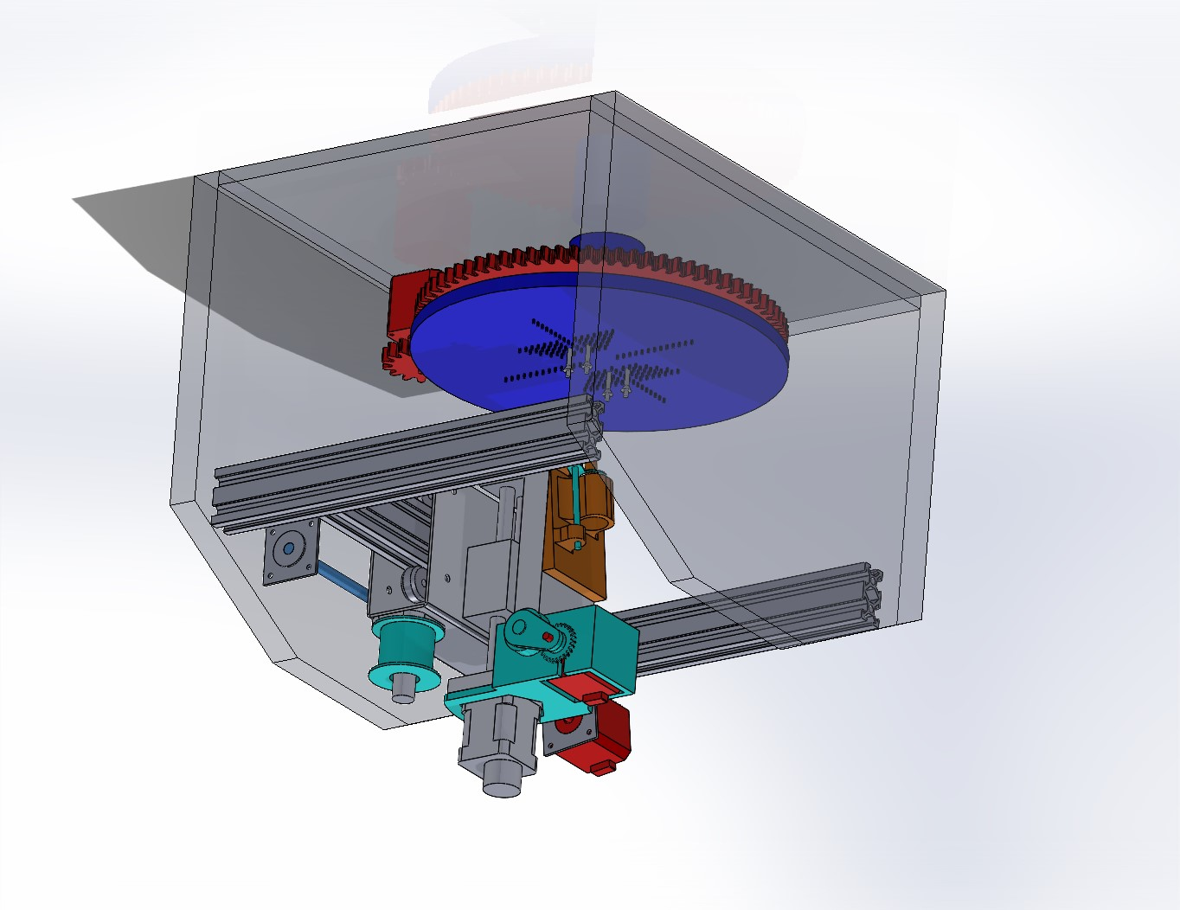

**SOLIDWORKS Educational Product. For Instructional Use Only.**

# Weekly Individual Contributions

|  |  |  |  |
| --- | --- | --- | --- |
| Name | Contributions | Mark | Signature |
| Reuben Smitheram | KT table.  Gear ratio.  Gear models.  Mountable turntable.  Assembly / exploded view. | 2 | Reuben |
| John-Luke Fenn | KT table  Designed base  Tried contacting Jullian | 2 | John-Luke |
| Lucas Kwan | KT table.  Designed soldering iron,  holder and feeder. | 2 | Lucas |
| Jack Edwards | KT table.  Gear ratio.  Motor mounts. | 2 | Jack |
|  |  | Sum=2*N |  |

N: number of group members. Every group member is expected to take part in the whole process, not just work on one part, for example, report writing only.

# Reference

References will not be included in word count

<https://khkgears.net/new/>

<https://www.pcbcart.com/article/content/elements-affecting-pcb-manufacturability.html#:~:text=Component%20height%20should%20be%204mm,between%20components%20should%20be%20consistent>.

<https://www.tempoautomation.com/blog/the-ultimate-design-guide-to-standard-pcb-sizes-specs/>

<https://www.bestpwb.com/metal-core-pcb/>

<https://jlcpcb.com/?from=VGRPCB_Prototype&gad=1&gclid=CjwKCAjw5remBhBiEiwAxL2M99LvCf6Hz13hFkcjjYmnhnfuaImg0EPQ6z_cOJISGXGYsDkfd3pVrBoCwoAQAvD_BwE>

<https://www.mokotechnology.com/guide-to-pcb-mounting-holes/>